Euler Tours

Example 1

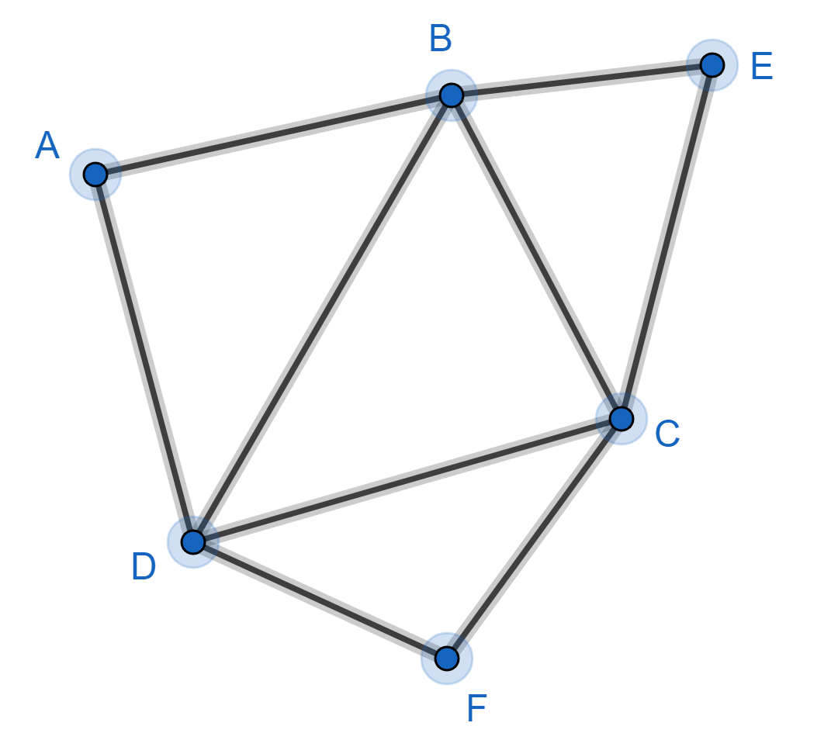

If you walk along the edges of this graph and visit the vertices in the order ABDCBECFDA then you have completed an Euler tour because you have walked along each edge once (and only once).
This is a closed tour because the end vertex (A) is the same as the start vertex (A).
Any tour can be reversed. You could walk ADFCEBCDBA
A closed tour can start on any vertex. We can think of the above tour as starting on vertex F. You could walk: FDABDCBECF

Example 2
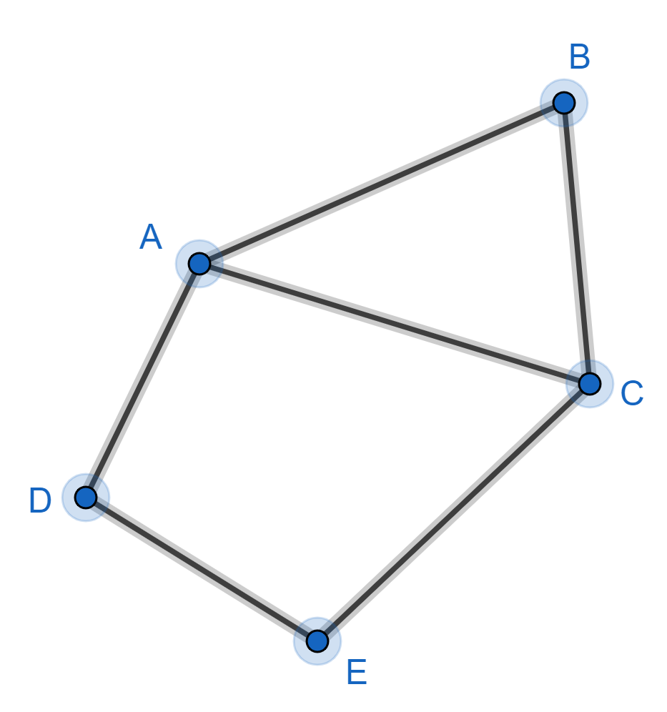

ABCEDAC is an open Euler tour because the end vertex (C) is not the same as the start vertex (A).
Any tour could be reversed. You could walk CADECBA
An open tour cannot start on any vertex.

Example 3
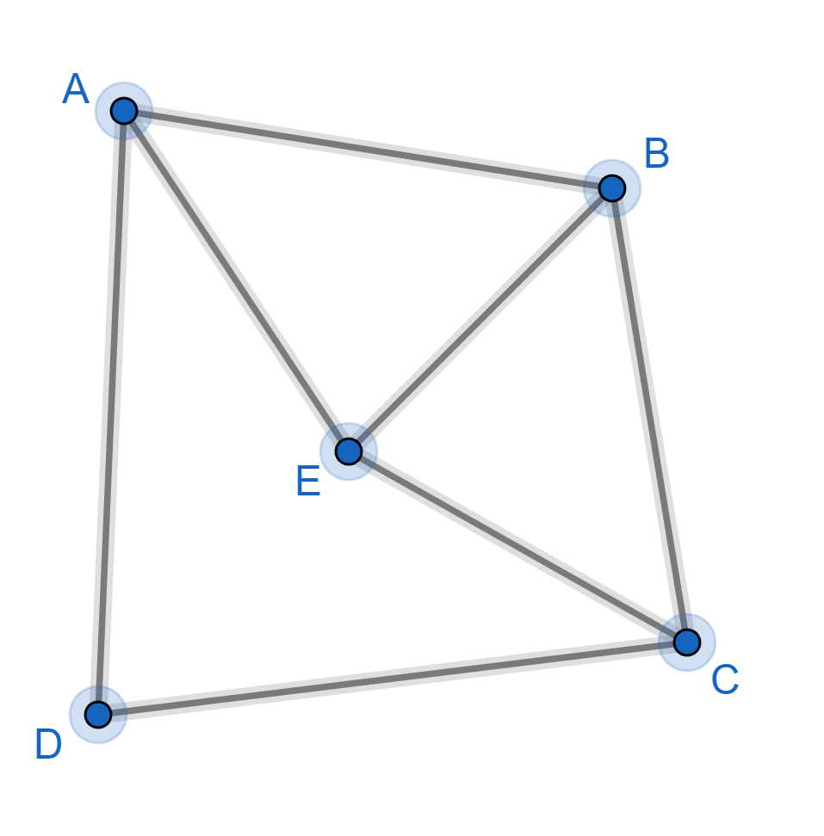

Does this graph have a closed Euler tour?
Let’s think about the start/end vertex of a tour:
If you start on vertex C, you can leave via one edge, return via another edge, leave again via the third edge but there is no edge left for your final return.
So you cannot start/end on vertex C (or vertex A, B or E)
The start/end vertex must be connected to an even number of edges.

Let’s think about the vertices that are not at the start/end of a tour:
Each time you go to a vertex via an edge, you have to leave this vertex via a different edge.
So you need an even number of edges connected to this vertex.

For a closed Euler tour, you need an even number of edges connected to every vertex.
So in our example, there is no closed Euler tour.

Does this graph have an open Euler tour?
Let’s think about the start/end vertex of a tour:
If you start on vertex C, you can leave via one edge, return via another edge, leave again via the third edge and you don’t need to return to vertex C.
The start/end vertex must be connected to an odd number of edges.

For an open Euler tour, you need an odd number of edges connected to the start and end vertices and an even number of edges connected to all the other vertices.
So in our example, there is no open Euler tour.

When you visit an art gallery, you want to walk along all the corridors, so you don’t miss any of the paintings. It would be good if you could return to the entrance without having to walk along any corridor more than once. Think of the corridors as edges and where corridors meet as vertices. A good art gallery lay-out would have no odd vertices.

Doodle Problem
Here is a doodle:

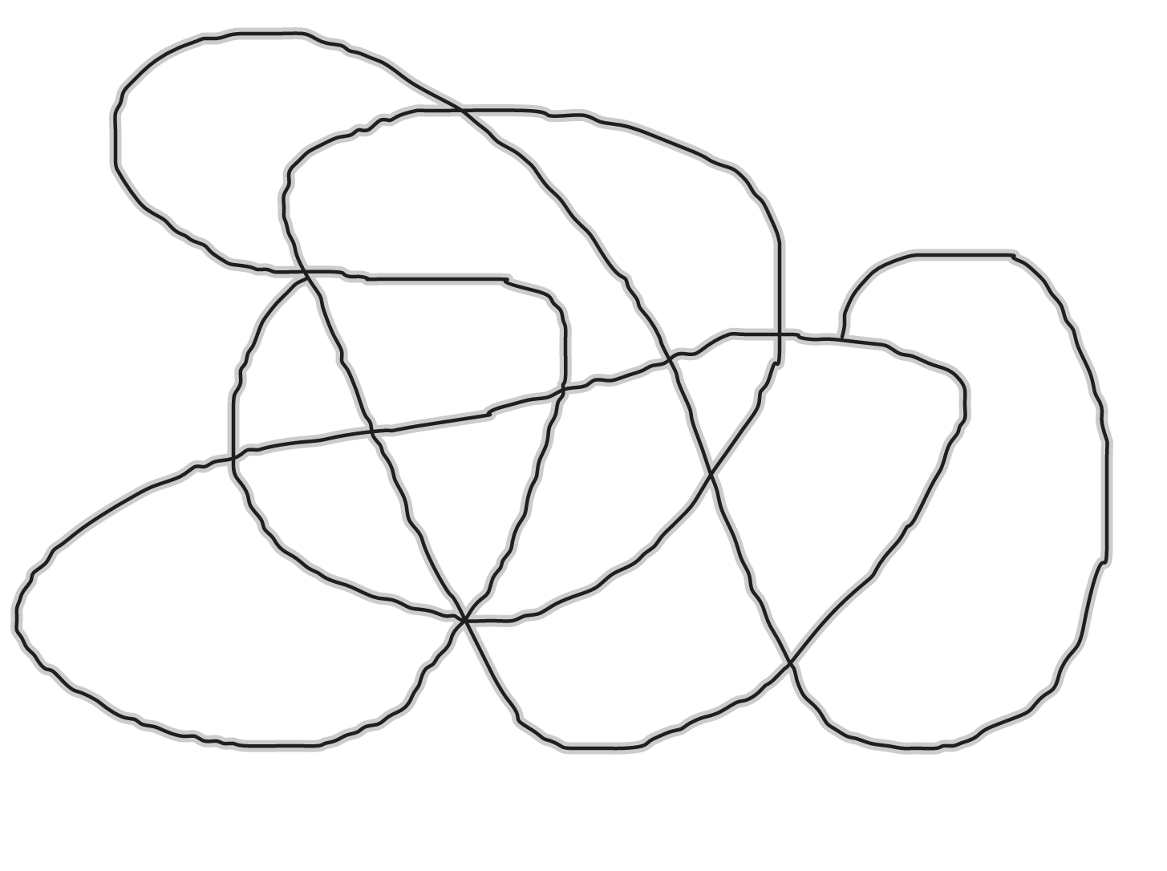

Can you draw this doodle without taking your pencil off the paper and without going over any part of the doodle more than once?
Put a vertex where lines meet and we have a graph. Drawing this doodle without taking your pencil off the paper and without going over any part of the doodle more than once is the same as finding an Euler tour. So we just need to count how many vertices are odd.
In this example there are 2 odd vertices, so you can draw this doodle by starting at one of the odd vertex and finishing at the other odd vertex.

Konigsberg Bridges Problem
Here is a map of the city of Konigsberg (now known as Kaliningrad):
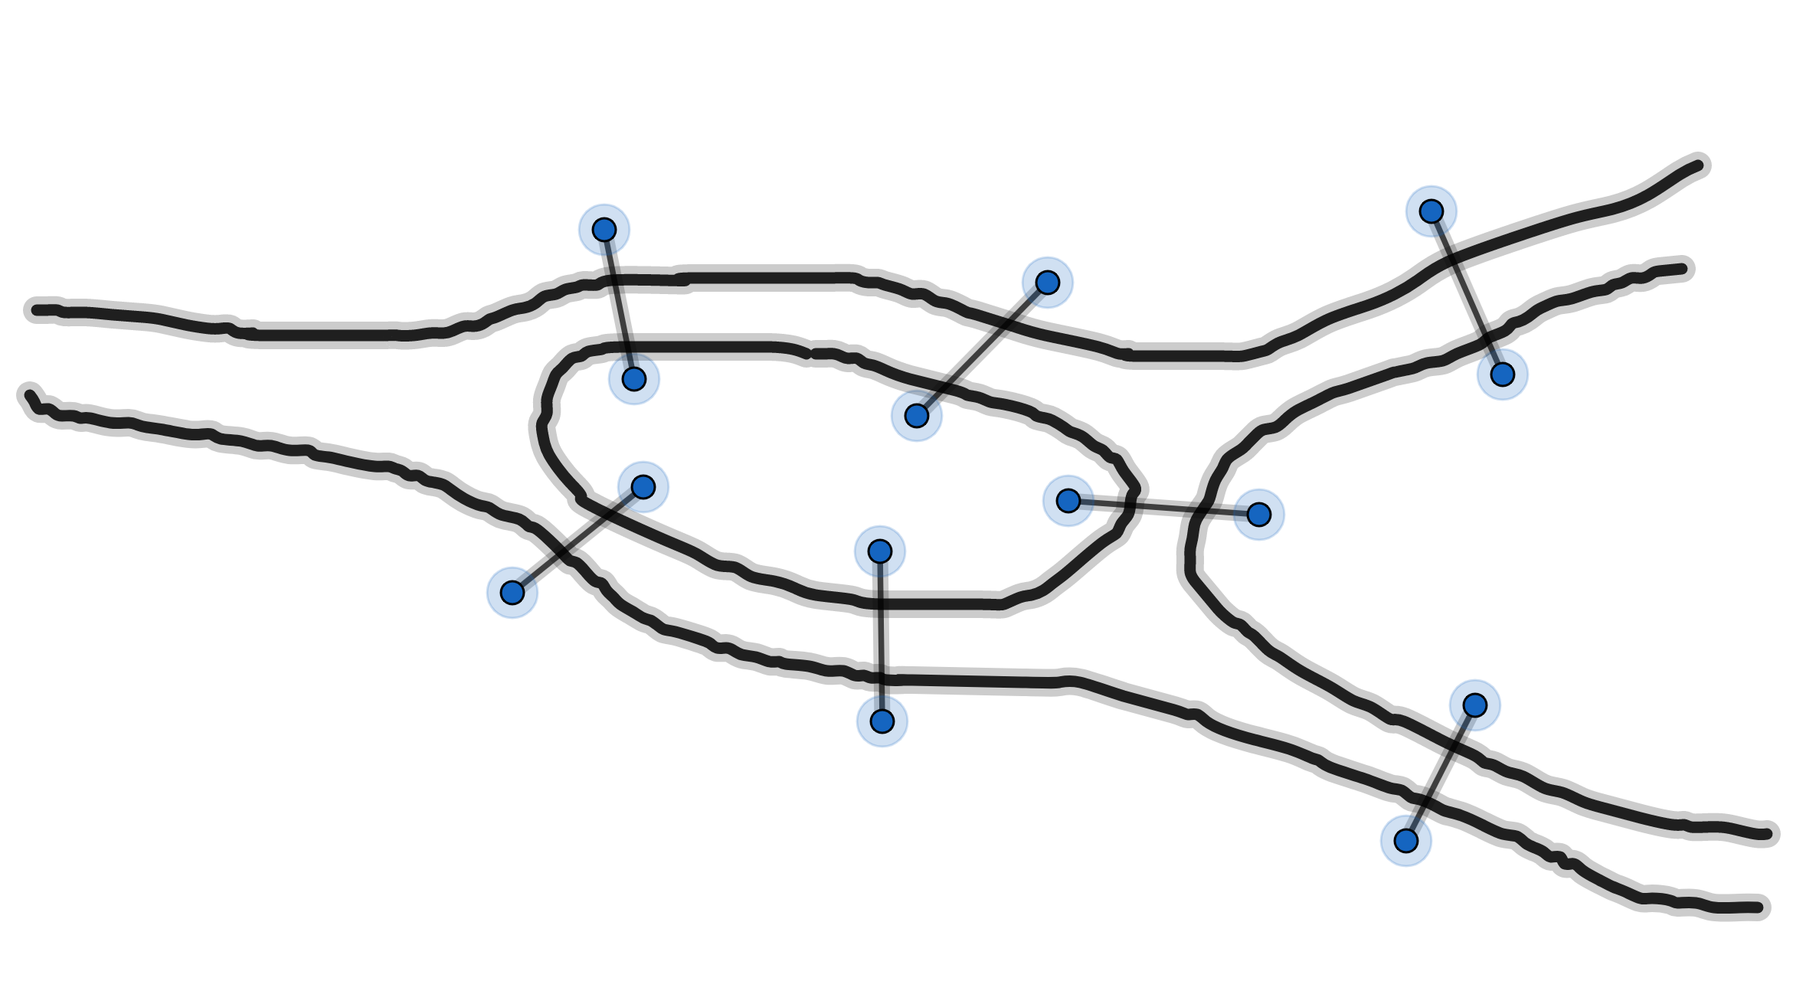

There is an island in the middle of a river. There are seven bridges connecting the island, the north bank, the south bank and the east area.
The story goes that citizens of Konigsberg wanted to go for a walk and cross each bridge once (and only once). Is this possible?
We can represent this map as a graph showing how the areas are connected by the bridges.

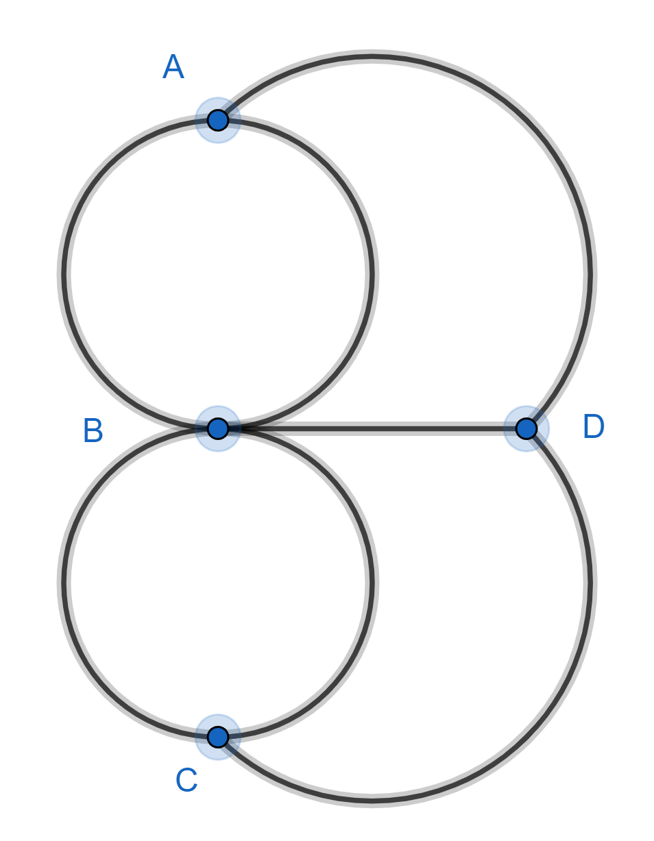

B is the island, A is the north bank, C is the south bank and D is the east area.
The citizens are trying to find an Euler tour. But this is not possible because there are 4 odd vertices.
It was Euler who first solved this problem, thereby starting a whole new branch of mathematics.

Chinese Postman Problem
Here is a street map of a town (drawn to scale):
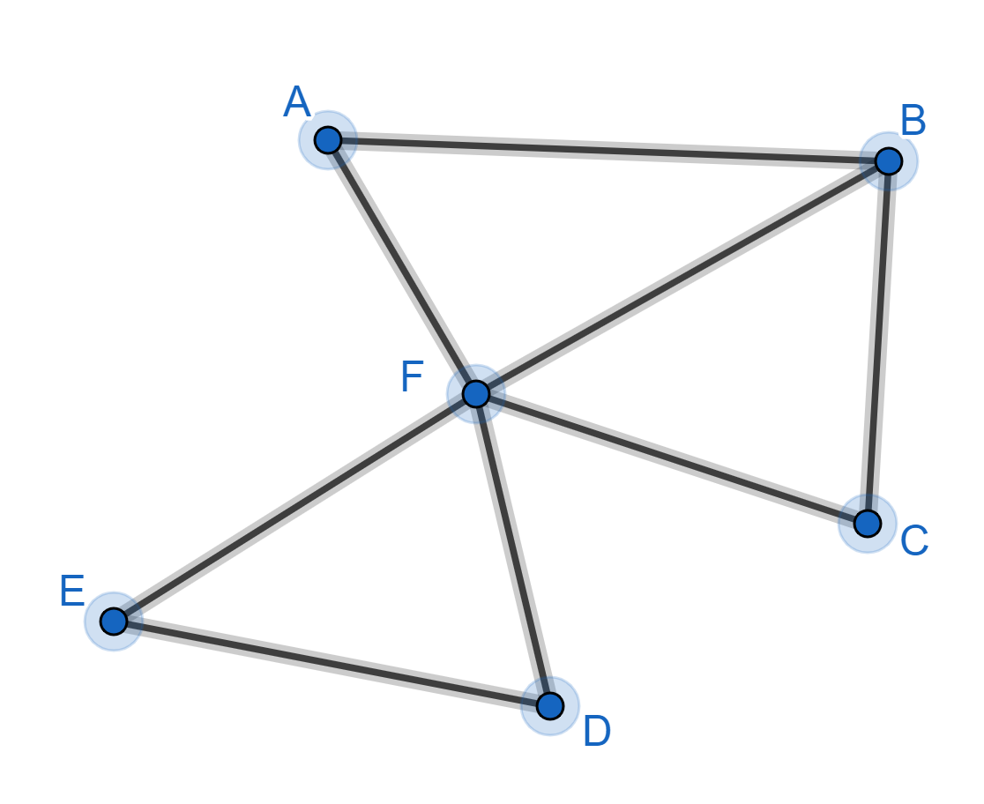

The postman starts at A, walks along every street delivering the mail, and then returns to A. The problem is to find the shortest route.
Think of the streets as edges and the street junctions as vertices and we have a graph.
If every vertex was even then the postman could take a closed Euler tour and walk along every edge once (and only once). But as some of the vertices are odd, the postman will have to walk along some edges twice.
B and F are the only odd vertices. The postman could start at B, walk along every edge once (and only once) and end at F. A possible route is BFCBAFEDF. The postman could then find the shortest route from F back to B. This is along edge FB.
We now have the closed non-Euler tour BFCBAFEDFB.
But the postman has to start and finish at A not at B. No problem. We can start a closed tour at any vertex. The tour AFEDFBFCBA will start and finish at A.
If there are more than 2 odd vertices then this problem is more difficult.

EXERCISE
1)
Do these graphs have Euler tours? If so, are they open or closed?
a)

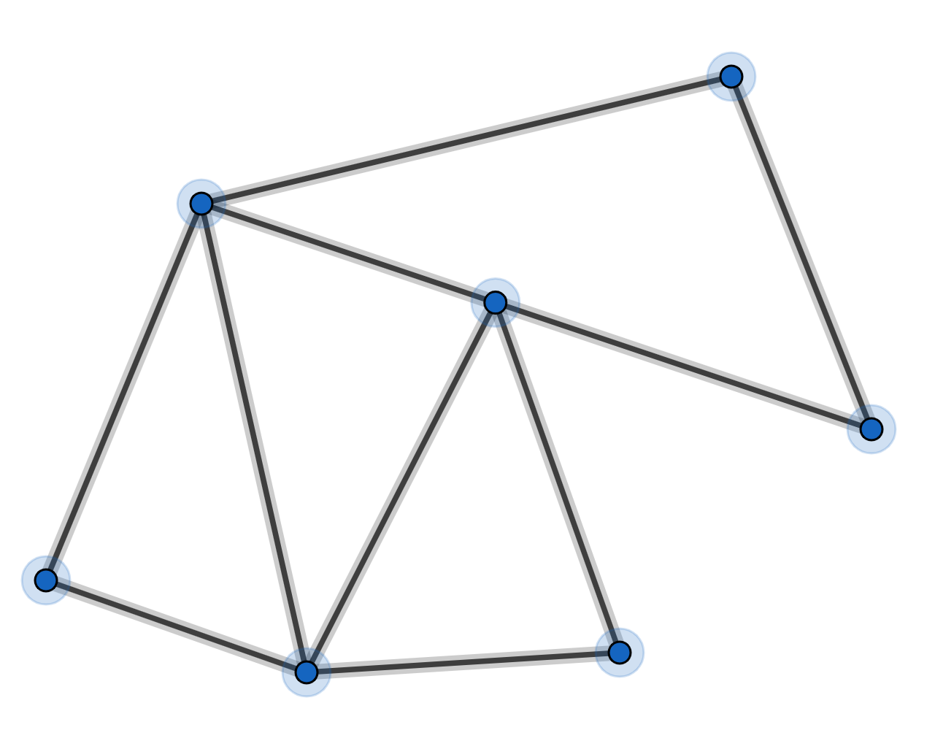

b)
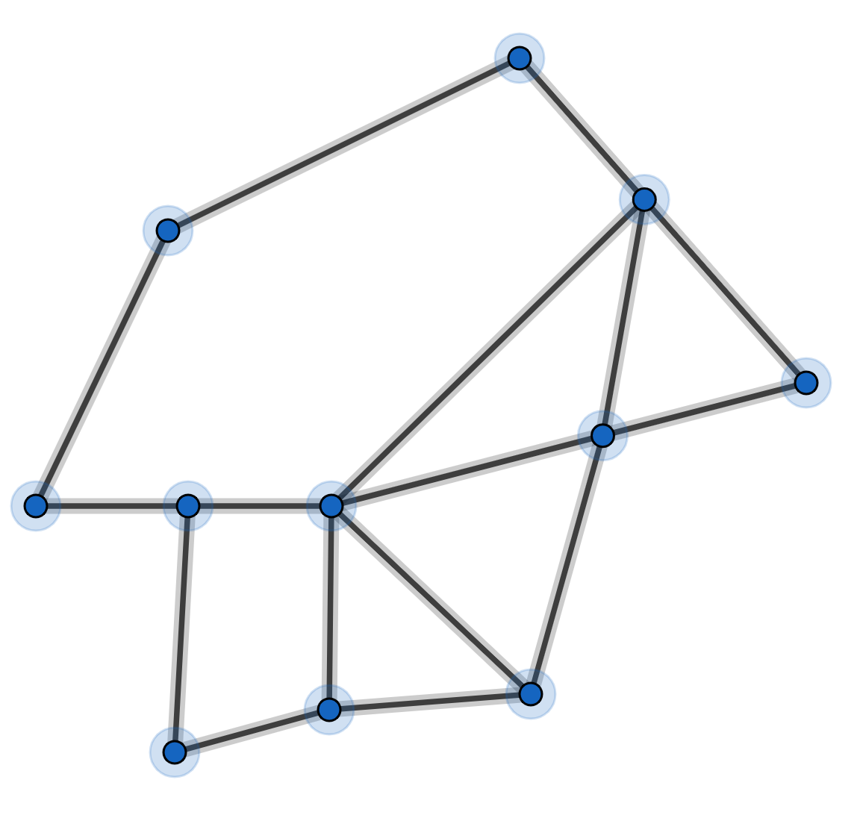

c)
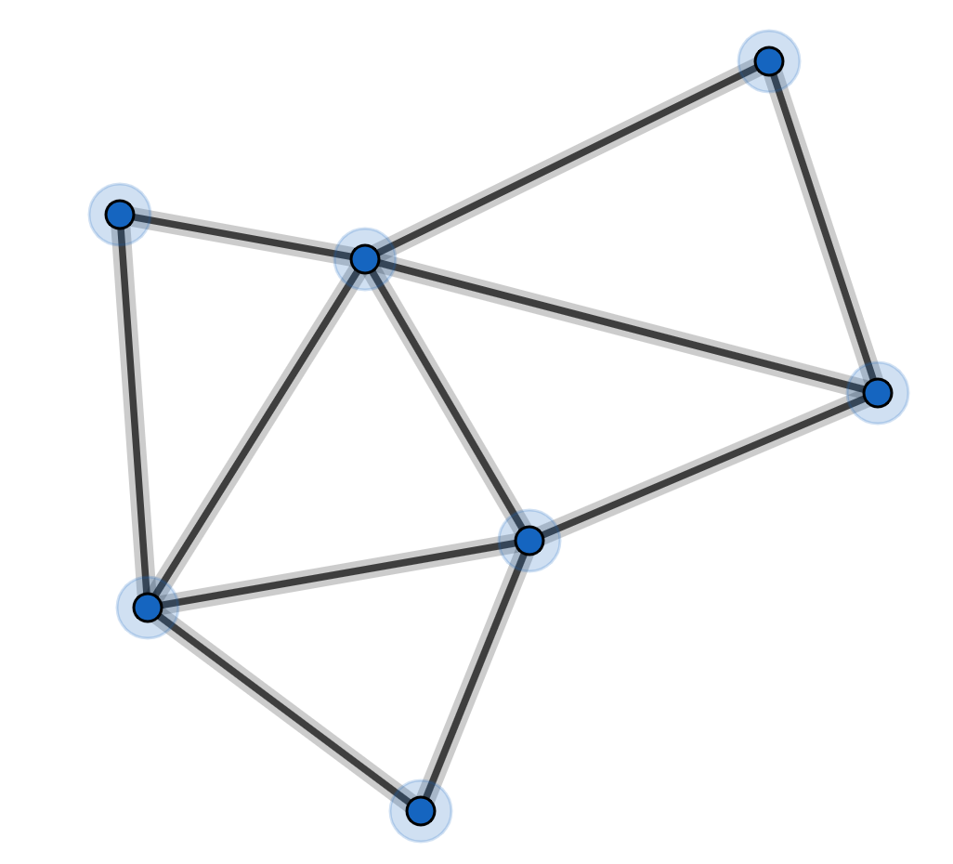

2)
Can you draw these doodles without taking your pencil off the paper and without going over any part of the doodle more than once?
a)
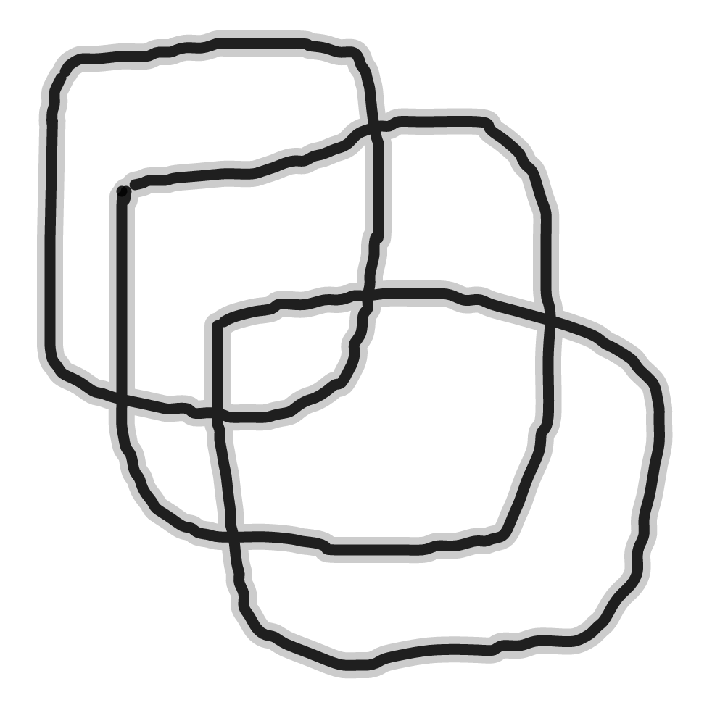

b)
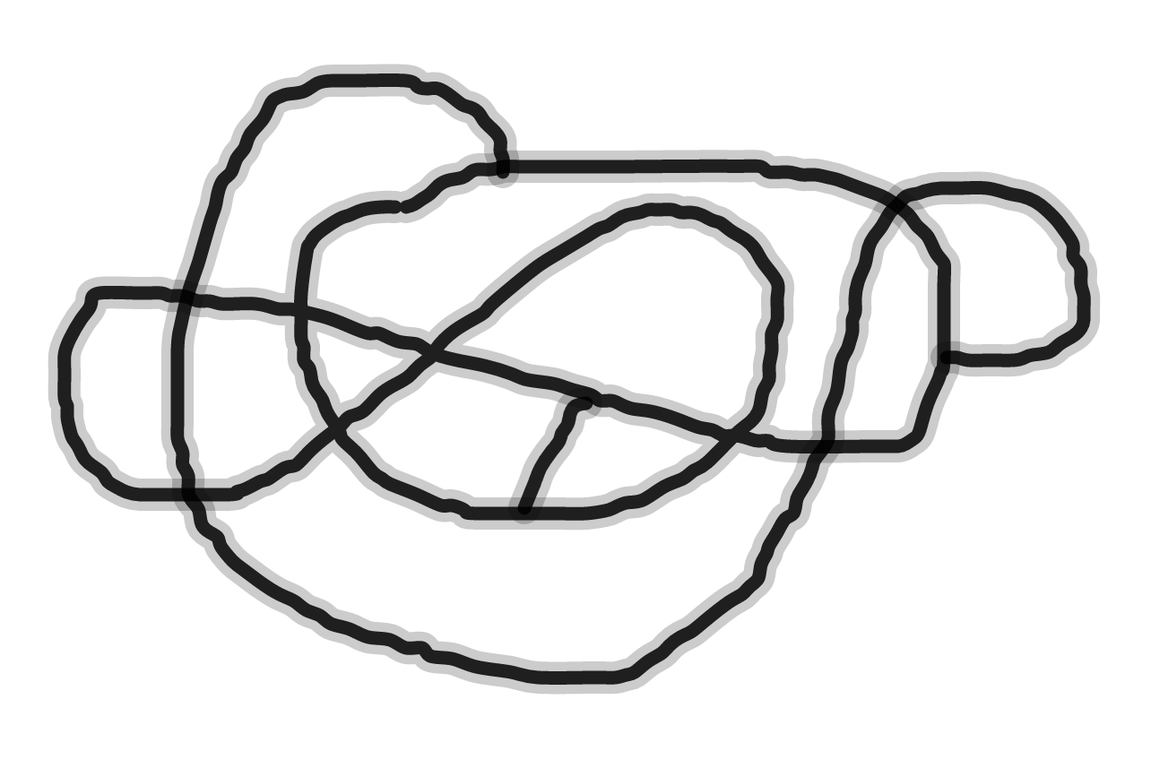

3)
Can you go for a walk and cross each bridge exactly once?
a)
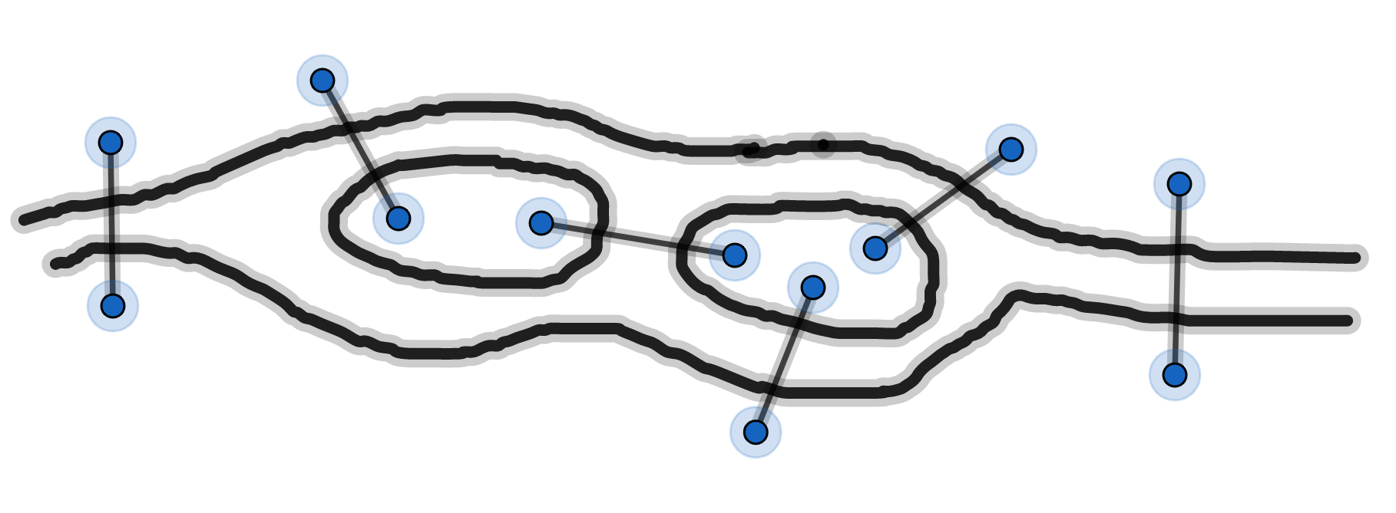

b)
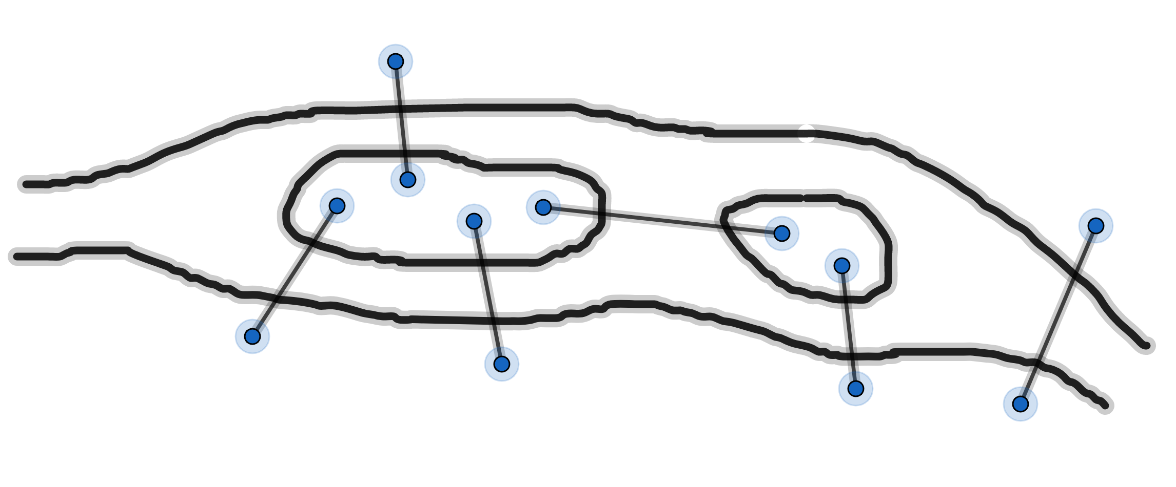

c) The mayor of Konigsberg wants to build another bridge so that she can go for a walk, starting from the north bank, crossing every bridge once (and only once) and ending on the island. Where should she build this new bridge?
4)
Here is a street map of a town (drawn to scale):
Find the shortest postman route starting and finishing at A.

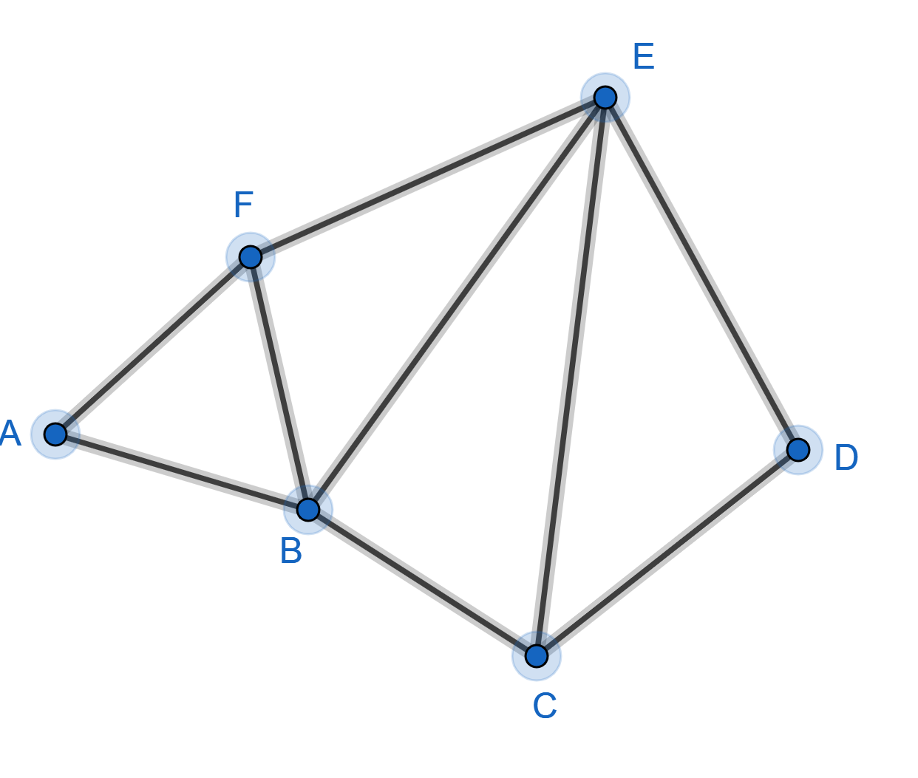

SOLUTIONS
1)
a) No odd vertices. So there is a closed Euler tour.
b) Four odd vertices. So there is no Euler tour.
c) Two odd vertices. So there is an open Euler tour.
2)
a) No odd vertices. Answer: Yes
b) Four odd vertices. Answer: No

3)
a) Two odd vertices. Answer: Yes
b) No odd vertices: Answer: Yes
c) The bridge must go between the south bank and the east area.
4)
F and C are odd vertices so let’s find an open tour starting at F and ending at C
for example: FEDCEBAFBC
Now let’s add on the shortest route from C back to F to get FEDCEBAFBCBF
Now let’s start/end this tour at A to get AFBCBFEDCEBA

